WATCH OUT FOR !!!
AMITES
(AQUIRING MINISTERS’ TEACHING SCHOOL)

For More Enquiries
Call: 08163776464 or 07039378043

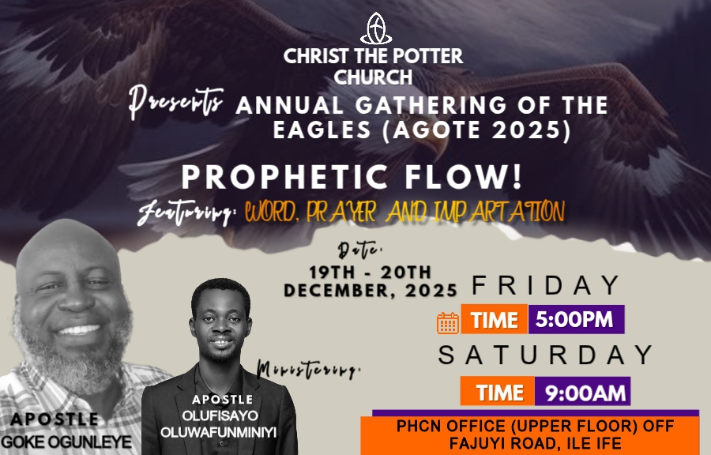

Welcome Address
Dear Beloved,
You are highly welcome to this year’s “ANNUAL GATHERING OF THE EAGLES (AGOTE 2025)” a gathering ordained by God to bless and enrich the lives of men with all it takes to obey Him.
The theme for this year’s edition is “DIVINE FLOW”.
We are gathered to experience God touching our lives through our Father-in-the-Lord. Apostle Goke Ogunleye.
Let’s be rightly positioned and postured to receive as we experience the DIVINE FLOW through the WORD, PAYERS and IMPARTATION.
As we have come and learn at the Lord's feet in these three days meeting, stay tune to the Holy spirit; I strongly believe God will do great and mighty things in our lives and ministries, there will be divine alignment in our assignment, He will stir up every divine deposits in the womb of our calling and impartations that will enable us to be more effective in the area of our Grace and calling and to promote unity in the body of Christ.

Stay Blessed.
Yours in Christ,
Apostle & Rev. (Mrs) Oluwafunminiyi Olufisayo
NOTES

NOTES

MINISTER’S PROFILE

Apostle Goke Ogunleye is a New Testament minister. He is the president of Alleluia to Jesus Ministries, the General overseer of Jesus faith Christian chapel. He serves as a life coach, trainer and covering to many ministers is in the body of Christ. He hold a weekly programme tagged faith trumpet church on air and other outreaches such as believer faith seminar which holds Bi-monthly.

He is a missionary by calling, teaching and preaching majorly on faith and redemption. His apostolic, prophet and teaching ministry has greatly impacted people live. His wife Rev. Mrs Subomi Ogunleye works together with him in ministry and they are blessed with three children. They reside in Osogbo, Osun State, Nigeria.

Apostle Oluwafunminiyi Olufisayo is an ordained minister of the gospel called and sent from God as a conference speaker and life trainer with an apostolic teaching and preaching mandate to teach men to walk in the reality of who Christ is. He is also passionate about seeing the order of God being established in the Church. His apostolic teaching has influenced, Inspired and transformed many lives in this Era.
He is the President of Oluwafunminiyi Samson Olufisayo Ministries and the Set Man of Christ The Potter Church.
He holds an Annual meeting tagged “GATHERING OF THE EAGLES”, a quarterly programme tagged “REALISED DESTINY SUMMIT”, a yearly programme tagged “REVELATION OF OUR SALVATION”, and also an Annual Conference for Ministers tagged: KINGDOM YOUNG MINISTERS’ CONFERENCE. He also holds a Teaching School-ACQUIRING MINISTERS’ TEACHING SCHOOL (AMITES) for those who have perceived the Call of God and those who are involve in church work. All these are set to teach and impact men to align with the ultimate counsel of God for their lives. He is happily married to Rev. Mrs. Olamide Olufisayo who also serves with him in the Ministry. They reside in Ile-Ife and they are blessed with two children, Aquila and Paul.
Schedule of Ministration
Date And Days | Morning Session | Evening Session
Friday  19th December |  | Apostle Oluwafunminiyi Olufisayo
Saturday 20Th December | Apostle  Goke Ogunleye

Programme of events

Friday 19th December 2025 Evening
5:pm - 5:05p.m. [5 mins.] Opening Prayers
5:05pm – 5:25 p.m. [20 mins] Shout of Praise
5:20pm – 5:40 p.m. [20 mins] Prayers and Supplication
5:40 pm – 5:50 p.m .[10 mins.] Introduction of The Minister
5:50 p.m – 7:25 p.m. [1hr 35 mins] Word Ministration
Apostle.OluwafunminiyiOlufisayo
7:25 p.m – 7:35 p.m. [10 mins.] Offering and announcements.

Saturday 2oth December 2025 Morning
10am – 10:10a.m. [10 mins.] Opening Prayers
10:10 –10:30 a.m. [20 mins] Shout of Praise
10:30 – 10:50 a.m. [20 mins] Prayers and Supplication
10:50 – 11:00 a.m. [10 mins.] Introduction of The Minister
11:00 a.m– 1:00 p.m. [2hrs ] Word Ministration
Apostle Goke Ogunleye
1:00 p.m – 1:10 p.m. [10 mins.] Offering and announcements.

ANNOUNCEMENTS

Christ The Potter Church is a place you need to always be for your divine training in Life and Destiny.

WORSHIP WITH US
Sunday Sunday service:8am
Tuesday School of prayer: 5pm
Thursday Revelational Hour: 5pm

The church operates a ministry Arm “Oluwafunminiyi Samson Olufisayo Ministries”

You can connect with us ONLINE via Facebook @christthepotterchurch

Visit the Media Stand to invest in your Spirit Man, “For Man shall not live by bread alone but by every word that proceeds from the mouth of God”

AVAILABLE MESSAGES

- CULTIVATING THE HABIT OF SEEKING AND RECEIVING DIVINE HELP IN THE TIME OF NEED.
- THE LAW OF GOING LITTLE FURTHER .
- UNDERSTANDING PRAYER AND THE HINDERACE THAT CHOKE THE EFFECTIVENESS.
- CONFLICT IN MARRIAGE AND HOW DEAL WITH IT.
- FAER IS NOT A CHRISTIAN VIRTUE.
- WHAT IS THE MESS HAVE YOU TRIED JESUS?
- FATHERING
- CONSECRATION
- WALKING IN THE FEAR OF GOD
- WALKING IN THE SPIRIT OF DISCERNMENT

